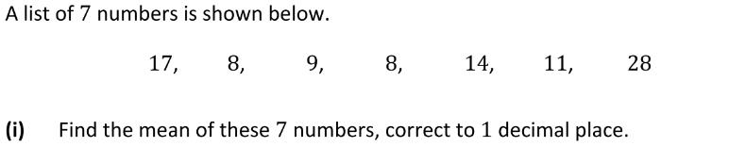

(17+8+9+8+14+11+28)/7

95/7=13.6



8 8 9 **11** 14 17 18



8 8 9 **10 11** 14 17 18

(10+11)/2=10.5

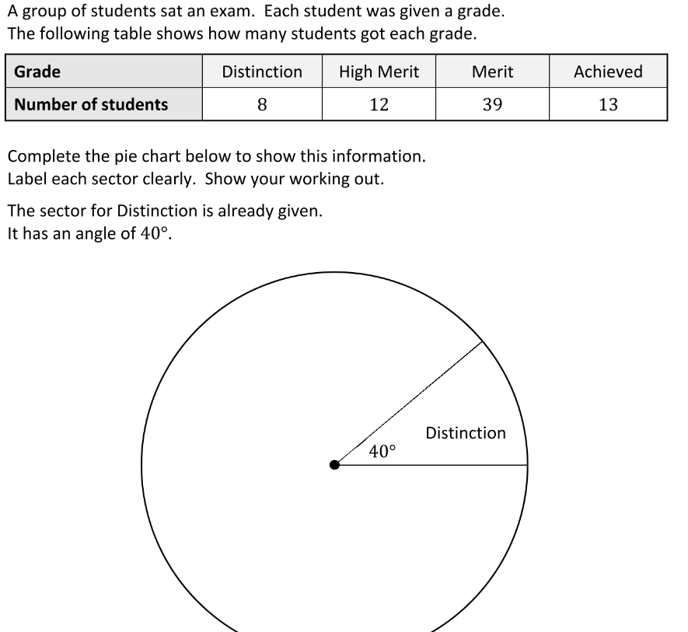

8+12+39+13=72

8/72=1/9*360=40°

12/72=1/6*360=60°

39/72=13/24*360=195°

13/72*360=65°

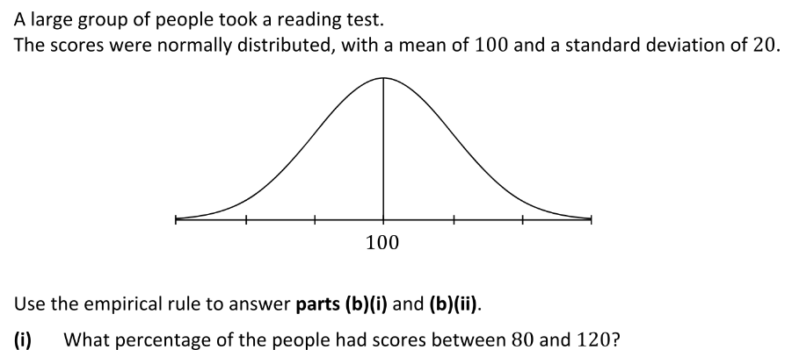

80 & 120 🡪 within one standard deviation of the mean.

68% of people had scores between 80 and 120.

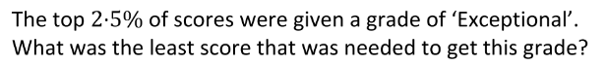

95% of graph between 2 standard deviations 🡪 2.5% below & 2.5% above.

Top 2.5% is then at least 2 standard deviations above the mean.

100+20+20=140.

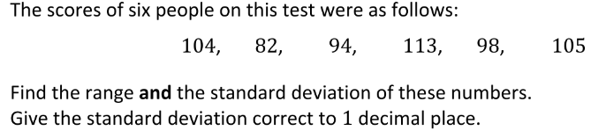

Range = 113-82=31

Mean = (104+82+94+113+98+105)/6

596/6=99.33

|  |  |  |
| --- | --- | --- |
| 104 - | 99.33 = | 4.67 |
| 82 - | 99.33 = | -17.33 |
| 94 - | 99.33 = | -5.33 |
| 113 - | 99.33 = | 13.67 |
| 98 - | 99.33 = | -1.33 |
| 105 - | 99.33 = | 5.67 |

(4.67)2+(-17.33)2+(-5.33)2+(13.67)2+(-1.33)2+(5.67)2

21.81+300.33+28.41+186.87+1.77+32.15=571.34

Variance = 571.34/6=95.22

Standard Deviation = $√95.22$ = 9.8

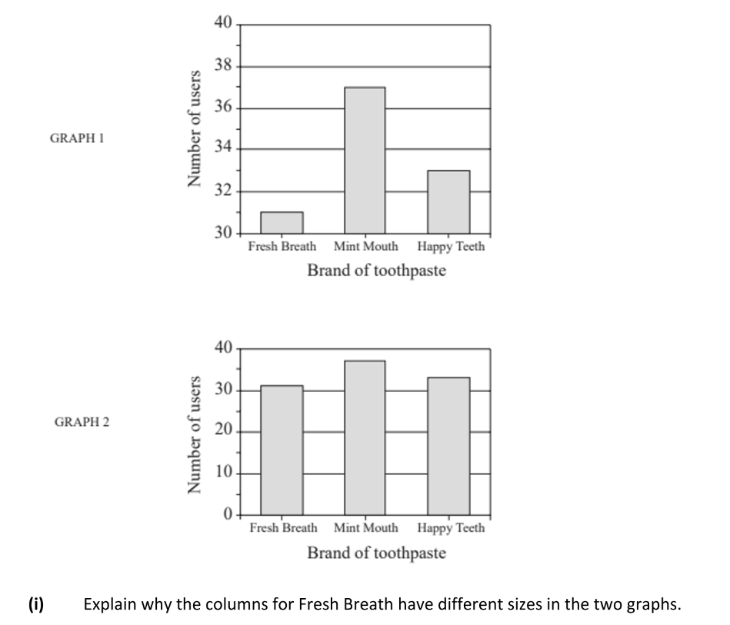

The top graph does not begin from zero, zooming in on the top of the graph bars, exaggerating the difference.



The top graph only shows where the columns end, to make it look like there is a bigger proportion of people who buy Mint Mouth. The graph is intentionally misleading.

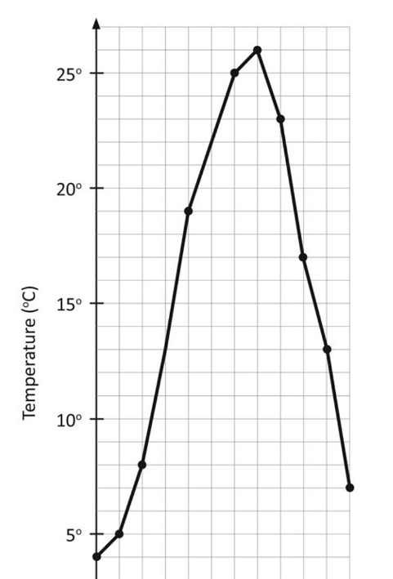

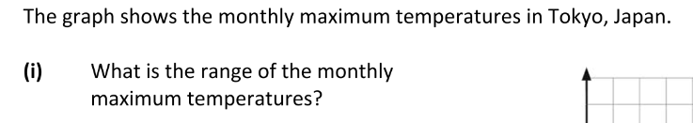

26-4=22

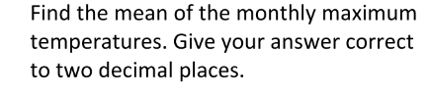

(5+6+8+13+19+22+25+26+23+17+13+7)/12

184/12=15.33